Intermediate Virtualization

Project: Infrastructure as a Code for VMware vSphere

Weight: 25% Marks: /100

Student Name:

Student ID:

Date:

This page was intentionally left blank.

Table of Contents

Project: Infrastructure as a Code for VMware vSphere 2

Introduction 2

Equipment and Materials 2

Procedure 3

Part A: Prepare the VMware vSphere Environment 3

Part B: Install and Initialize Terraform 4

Part C: Manage VMware Resources with Terraform 6

Part C: Demonstrations 14

Marking Criteria 16

Resources 17

References 17

Instructor Notes 17

# Project: Infrastructure as a Code for VMware vSphere

## Introduction

In this project, you’ll combine the concepts you’ve learned in the course with independent research to use an infrastructure as a code (IaC) tool, Terraform, to provision, update and manage VMware vSphere resources. Terraform software is used by organizations to manage IT infrastructure in a programmatic manner.

This individual project relies on your ability to seek out information in course documents and online resources to determine the appropriate steps to achieve your desired result. You will demonstrate your completed project to your instructor.

## Equipment and Materials

* Windows computer with a minimum of 32 GB RAM and 250 GB free disk space.
* VMware Workstation 16.x or higher
* VMware vSphere 7.0 or higher
* Terraform v1.7.2 or higher
* An NFS server

## Procedure

### Part A: Prepare the VMware vSphere Environment

Complete this part of the project individually outside of class time.

1. Working individually outside of class time, install two VMware ESXi hosts and install vCenter Server on one of the hosts.
2. Create an NFS server for shared storage that is accessible from both ESXi servers.

**Note:** vCenter Server’s Tiny Deployment requires 12 GB RAM. Ensure that the target ESXi host has at least 13 GB RAM.

1. Create a datacenter in vSphere Client, and then add the two ESXi hosts to the datacenter.

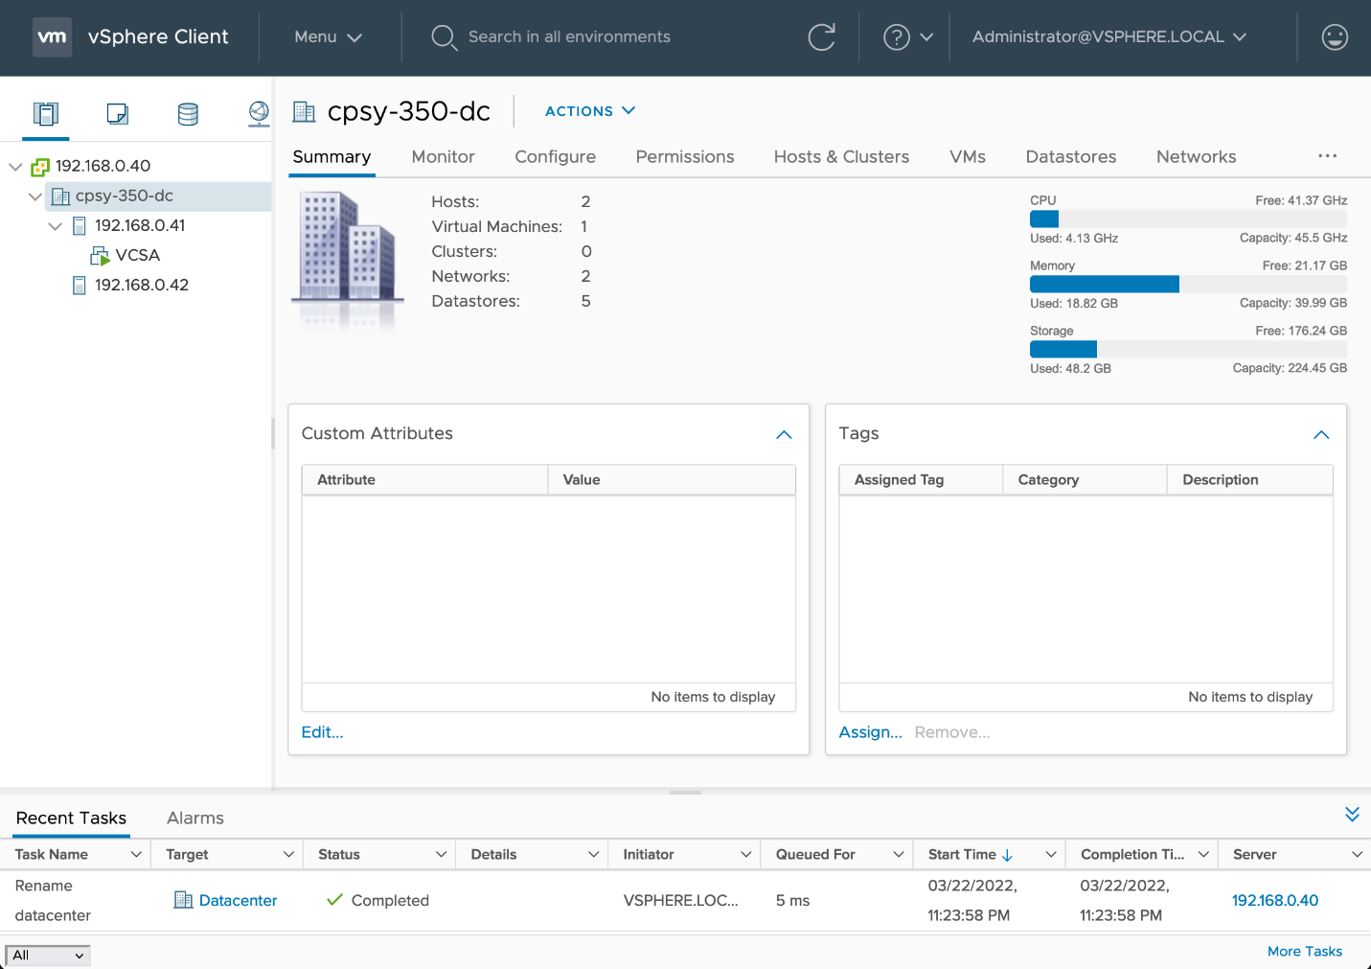

Figure 1: vCenter Server and Virtual Datacenter

Source: VMware, Inc., 2022. Reproduced and used in accordance with the fair dealing provisions in section 29 of the Canadian Copyright Act for the purposes of education, research or private study. Further distribution may infringe copyright.

### Part B: Install and Initialize Terraform

Complete this part of the project individually outside of class time.

1. Go to the website [Install Terraform](https://developer.hashicorp.com/terraform/tutorials/aws-get-started/install-cli) (<https://developer.hashicorp.com/terraform/tutorials/aws-get-started/install-cli>) and follow the instructions to install the Terraform command line interface tool on the operating system of your choice. Terraform’s official packaging guide: <https://www.hashicorp.com/official-packaging-guide?product_intent=terraform>
2. Paste the following code into a file and name it **main.tf**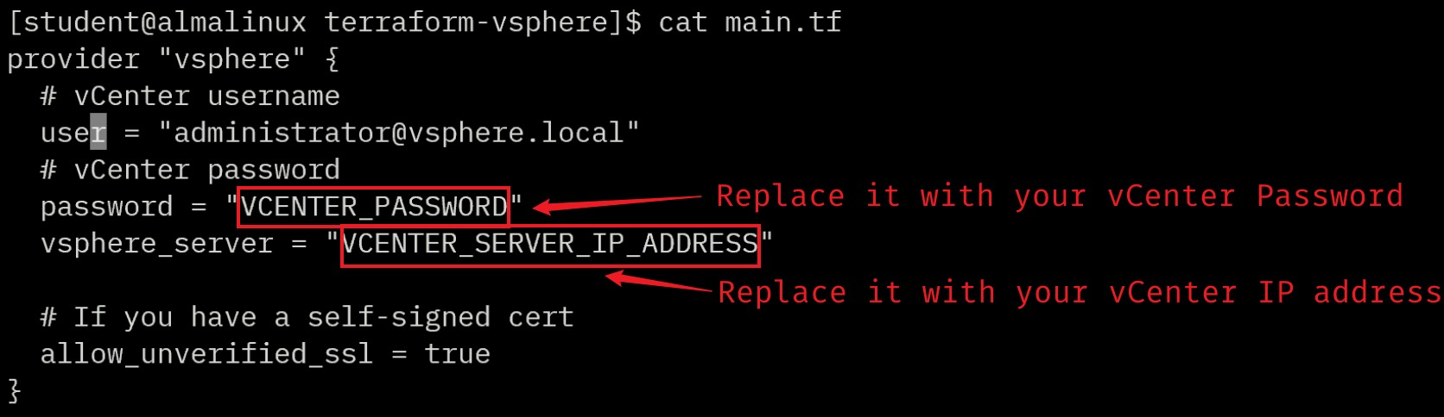
3. Run **terraform init** to download a plugin that allows Terraform to interact with VMware vSphere.

**Note:** You only need to initialize the project once.

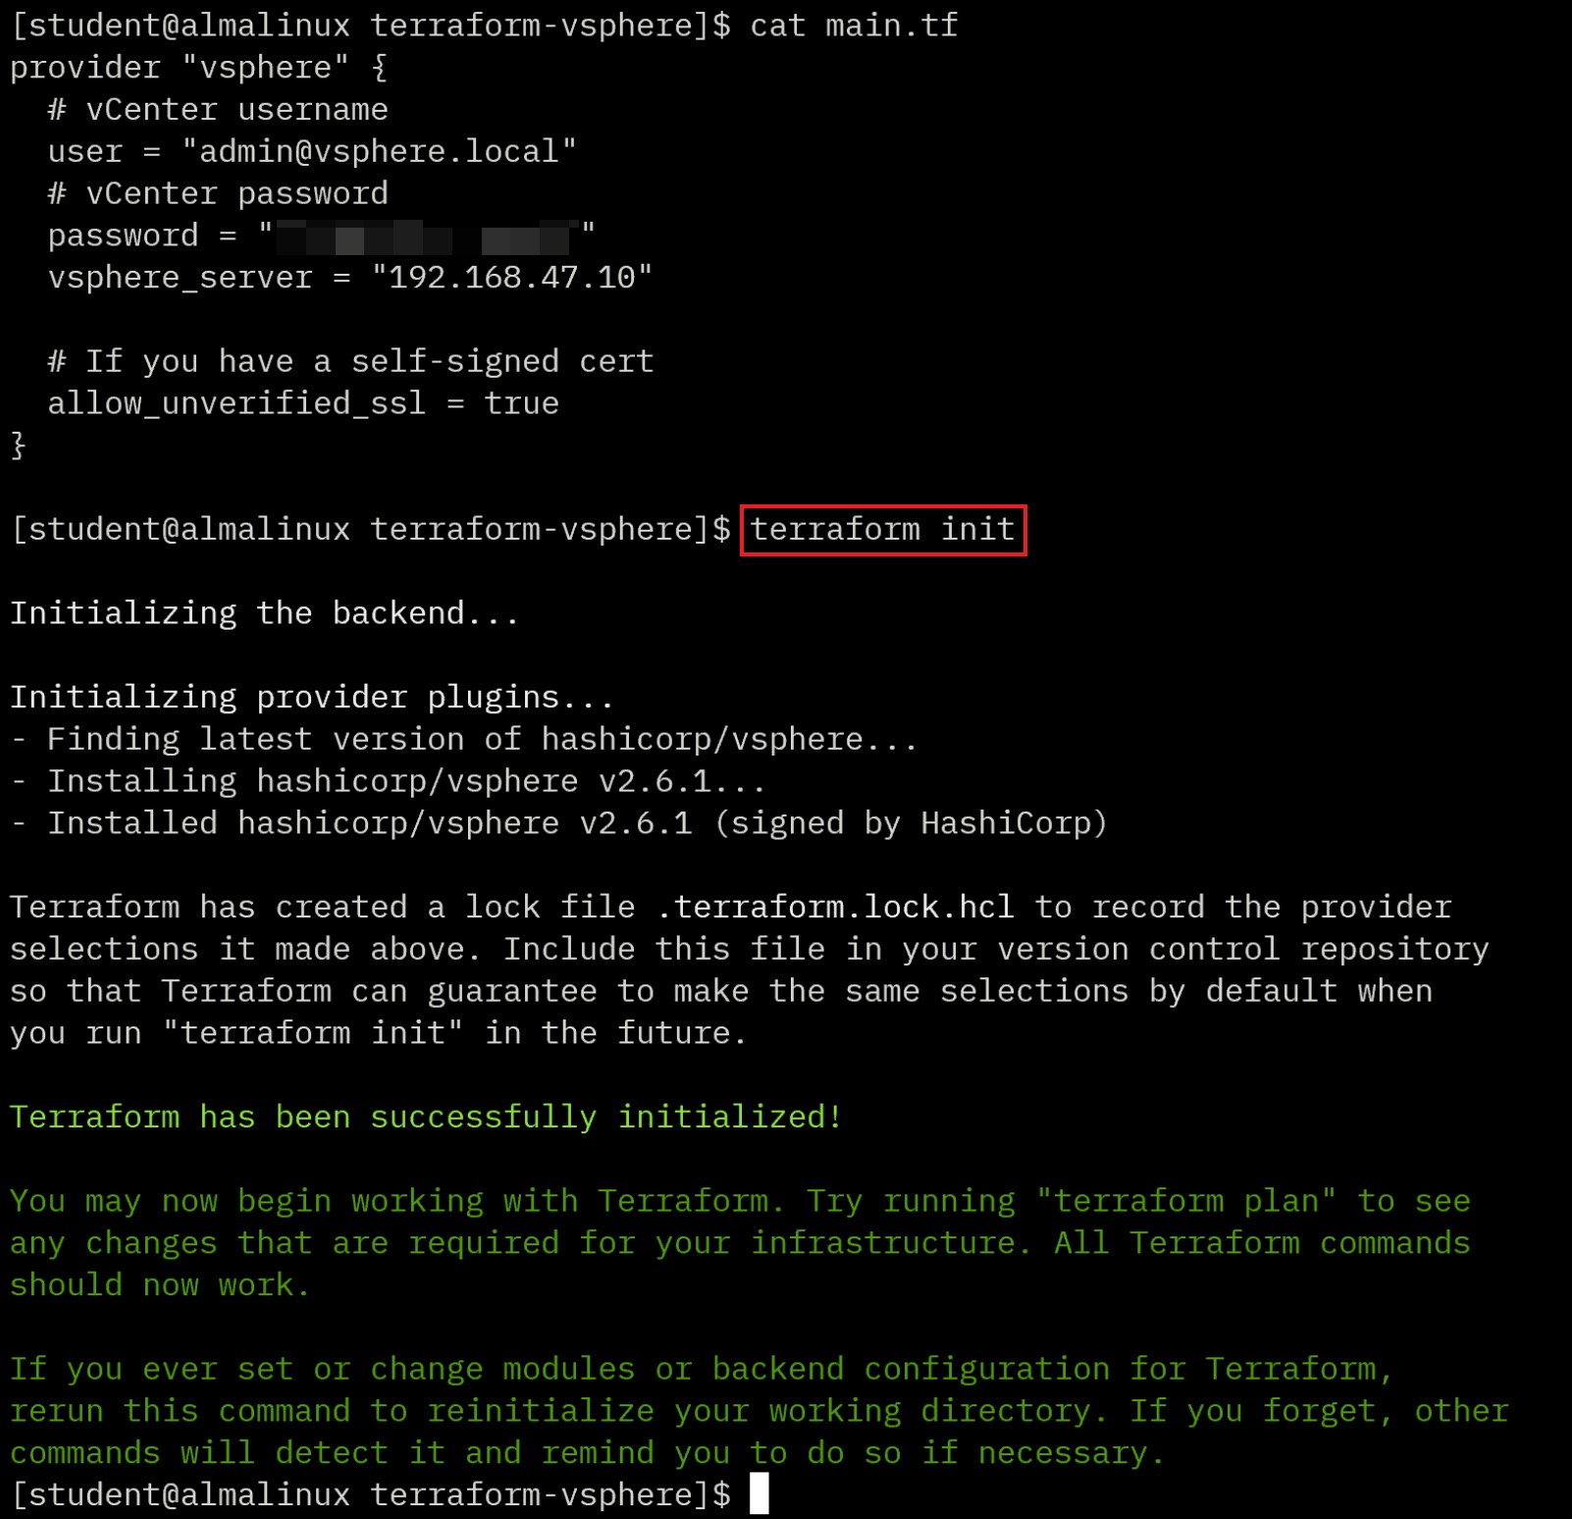

### Part C: Provision a VM in vSphere vCenter with Terraform

In this part of the project, you will write configuration code in **main.tf** to create a virtual machine in vSphere vCenter. Then you will destroy the created VM with Terraform.

1. Place the host without vCenter VM in Maintenance Mode to ensure that there is only one ESXi host can be used to deploy VM (This step is optional if all ESXi hosts have shared NFS datastore). Create a resource pool named `**rp-part-c**` on the ESXi host that is **NOT** in maintenance mode.  
   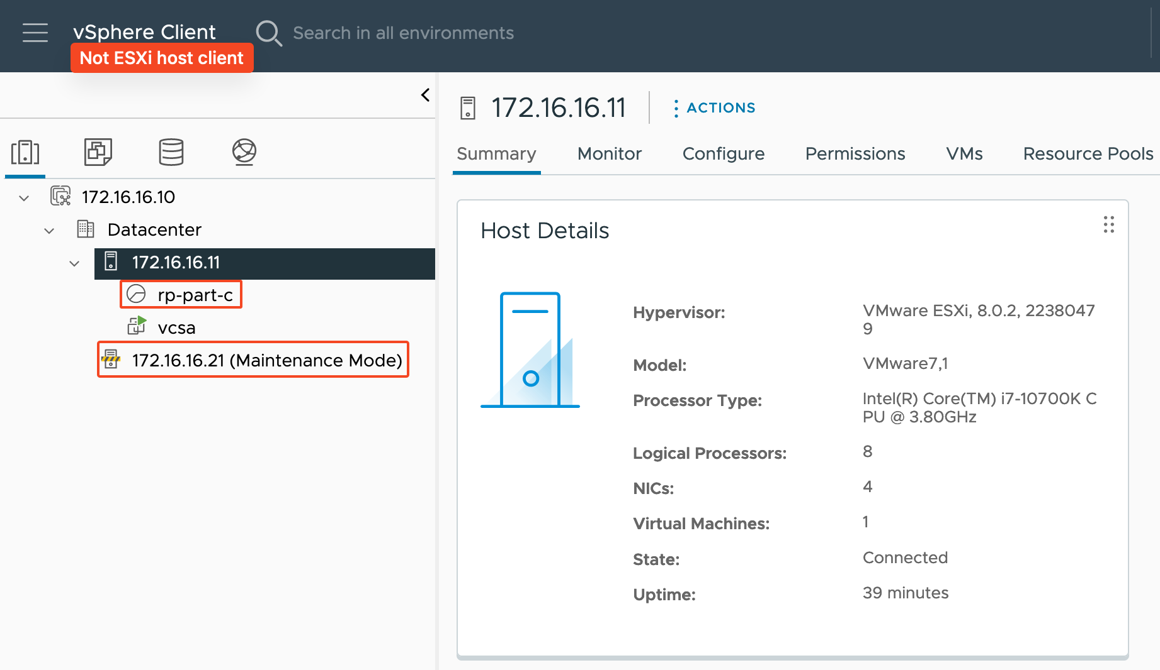
2. Download the [Alpine Linux ISO file](https://alpinelinux.org/downloads/) (<https://dl-cdn.alpinelinux.org/alpine/v3.19/releases/x86_64/alpine-virt-3.19.1-x86_64.iso>), and then upload it to a local datastore.  
   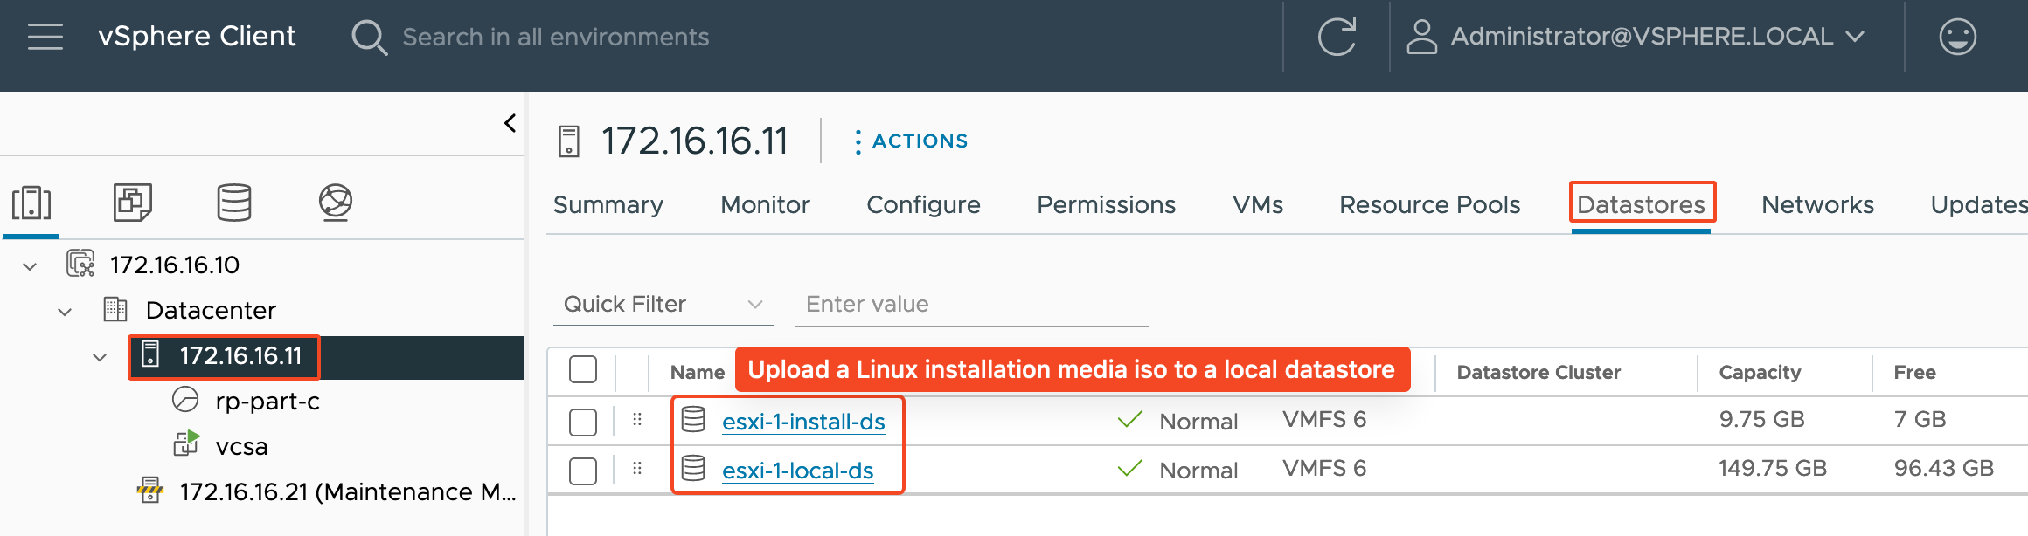  
   Uploaded iso image:  
   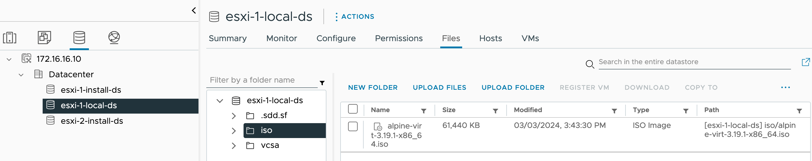  
   Note: Take a note of iso file path. You will need it in next step.
3. Use Terraform to create a VM named “**tf-vm-YOUR_SAIT_ID**” with the following specifications:

* 1 CPU
* 256 MB RAM
* Connect network adapter 1 to **VM Network**.
* 1 GB HDD on a local datastore
* 1 CD/DVD drive with the uploaded Alpine Linux ISO file from the local datastore

**Hint**: Modify the code from “Example Usage” section of <https://registry.terraform.io/providers/hashicorp/vsphere/latest/docs/resources/virtual_machine> and add it to **main.tf** below **provider "vsphere"** block.  
Read <https://registry.terraform.io/providers/hashicorp/vsphere/latest/docs/data-sources/resource_pool#specifying-the-root-resource-pool-for-a-standalone-host> to define resource pool.  
CD-ROM options: <https://registry.terraform.io/providers/hashicorp/vsphere/latest/docs/resources/virtual_machine#cd-rom-options>  
Add `**wait_for_guest_ip_timeout = 0**` and `**wait_for_guest_net_timeout = 0**` to the resource block to prevent timeout waiting for an available IP address error.  
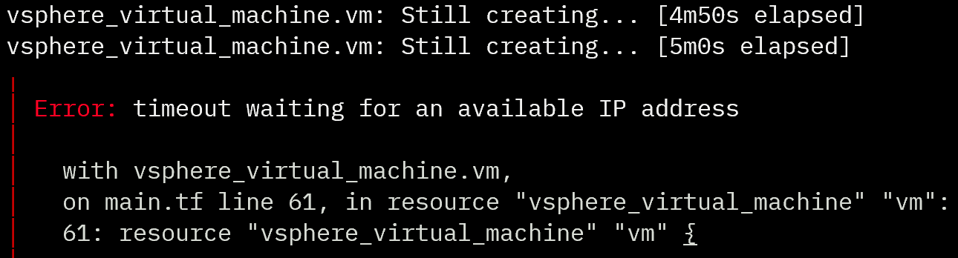  
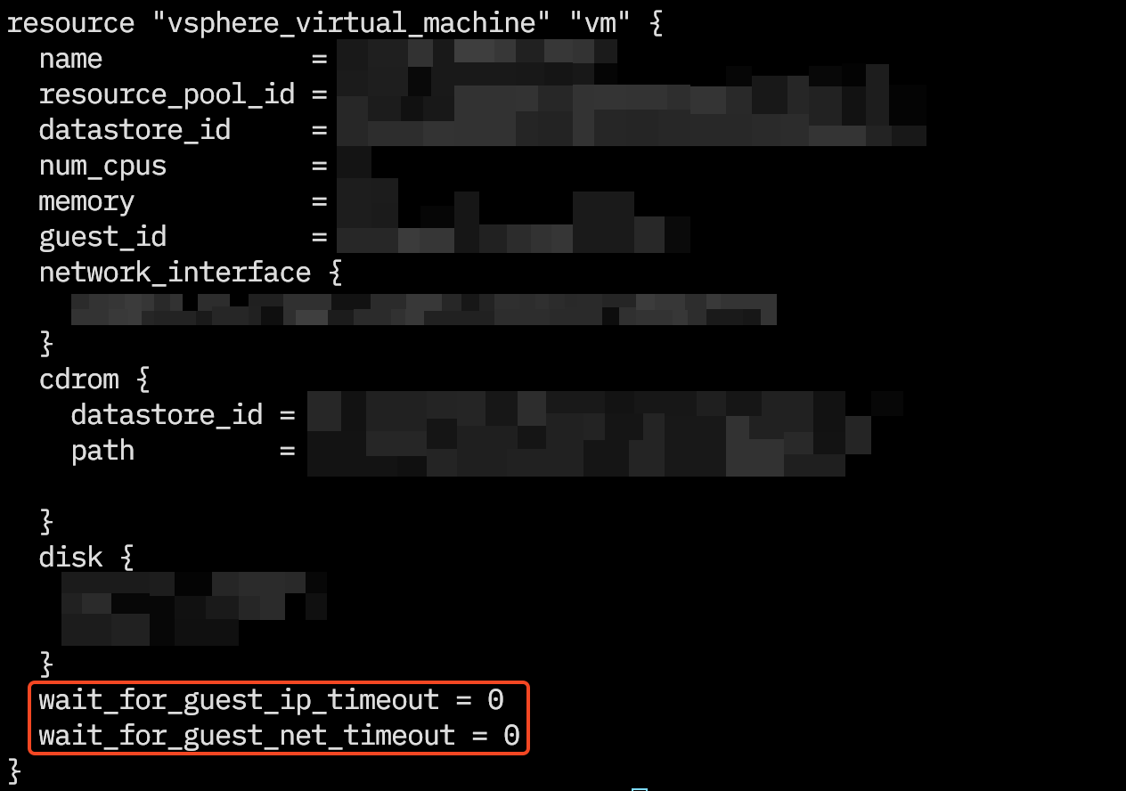

1. Deploy it by running the command **terraform apply**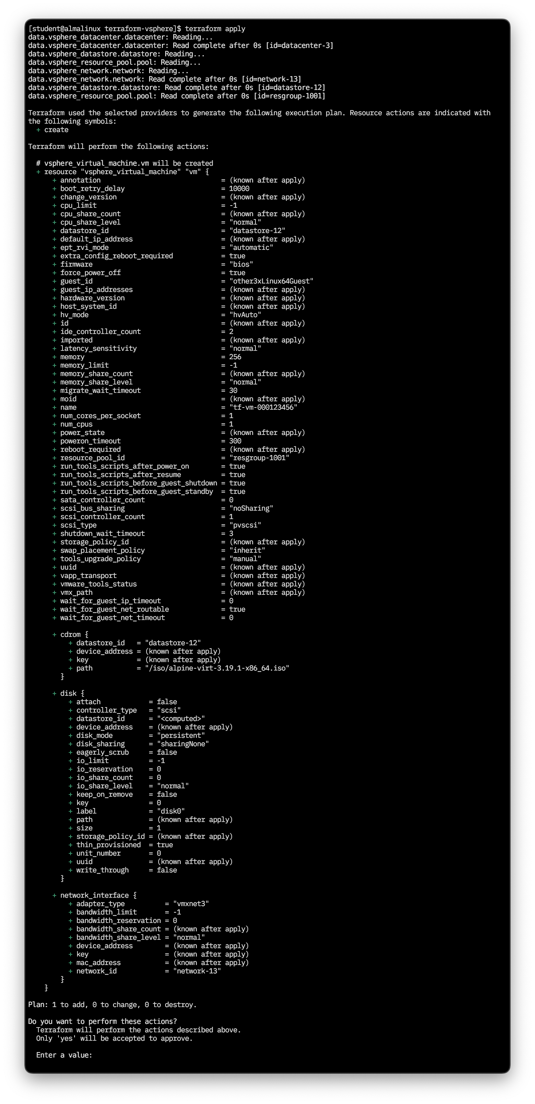
2. When asked “Do you want to perform these actions?” type **yes** and then press **ENTER**.  
   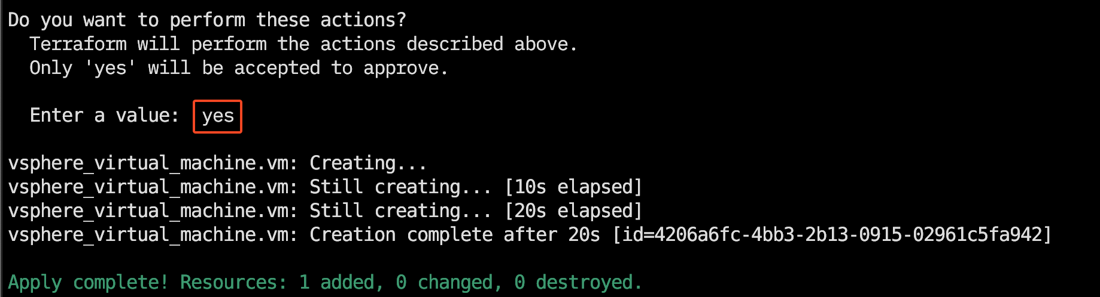
3. Verify that the VM with correct specs is correctly created in vSphere Client.  
   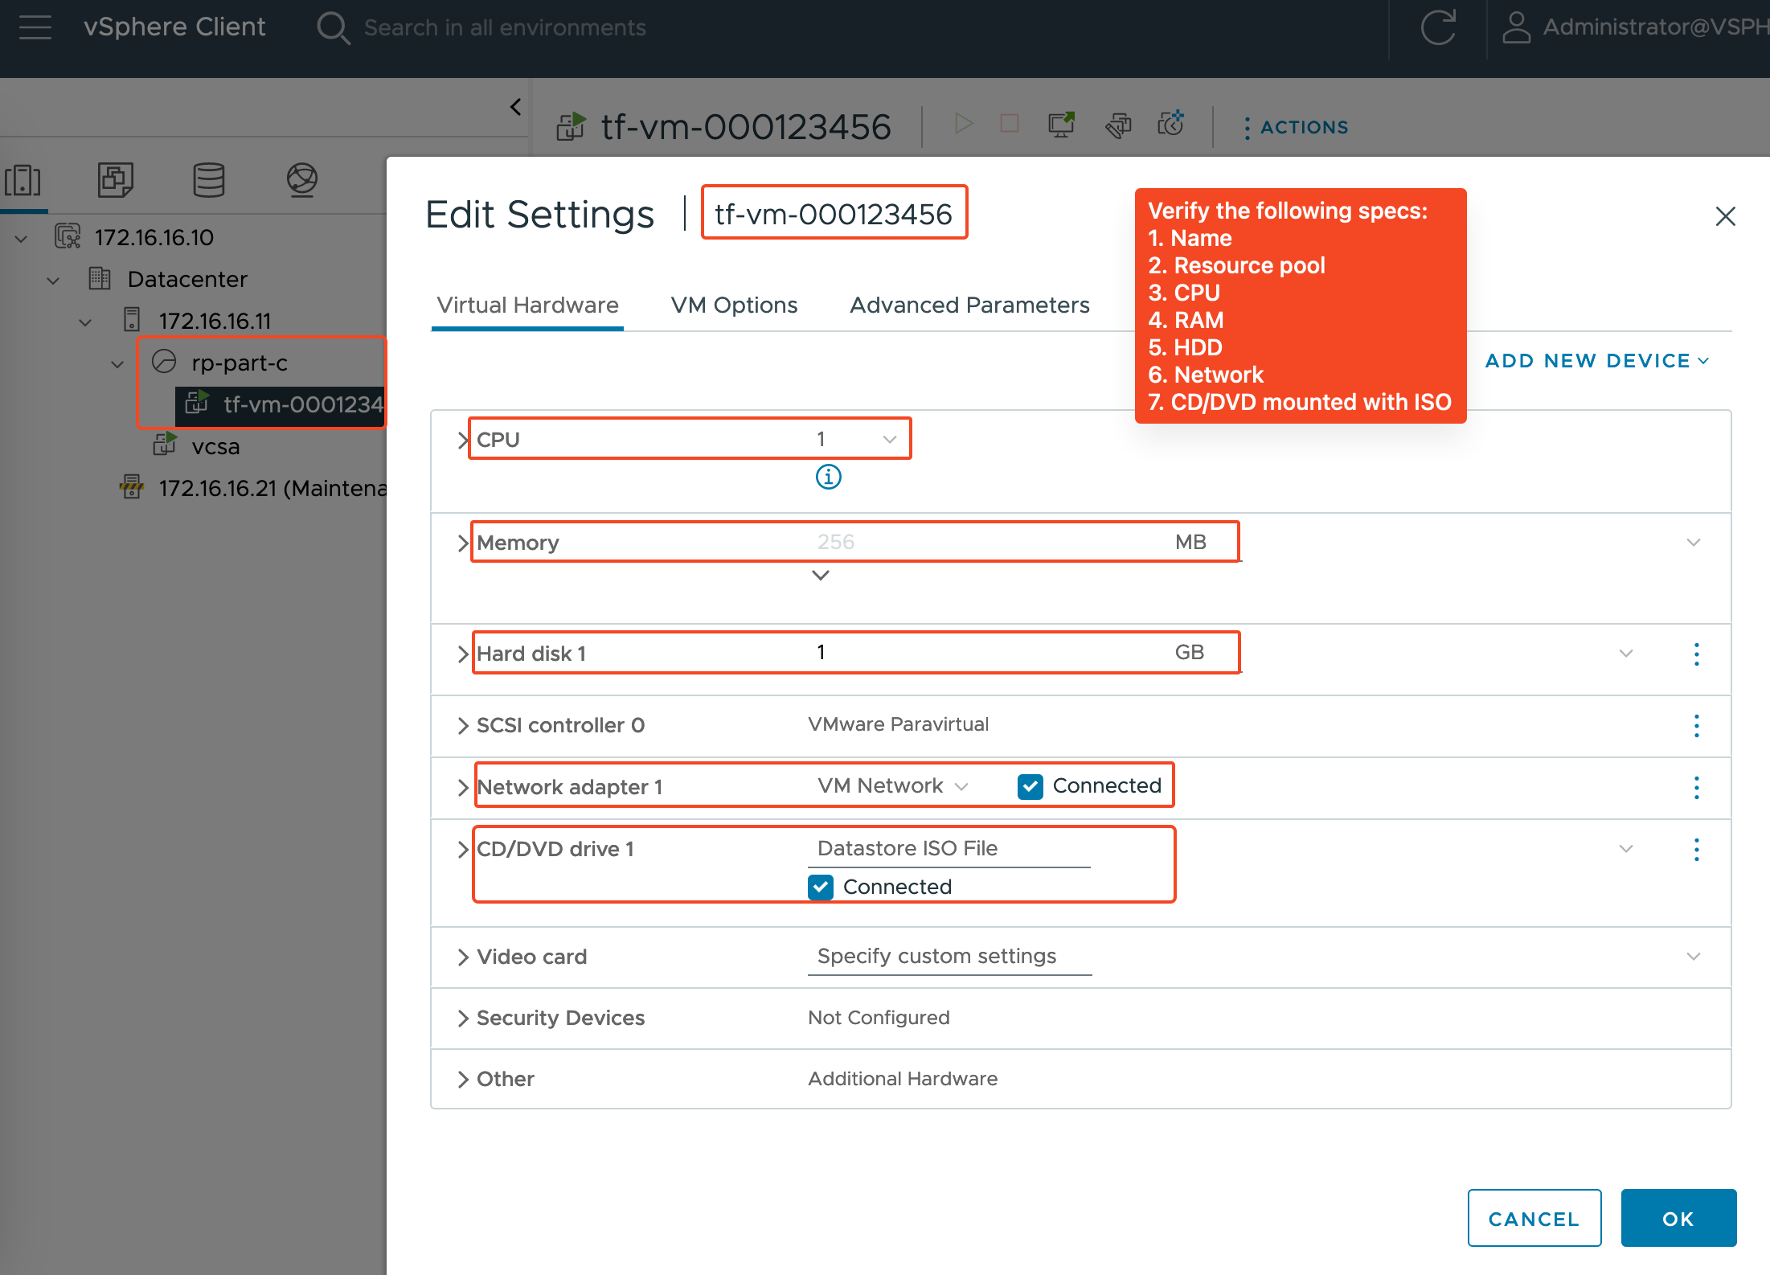
4. Run `terraform destroy` to destroy the VM  
   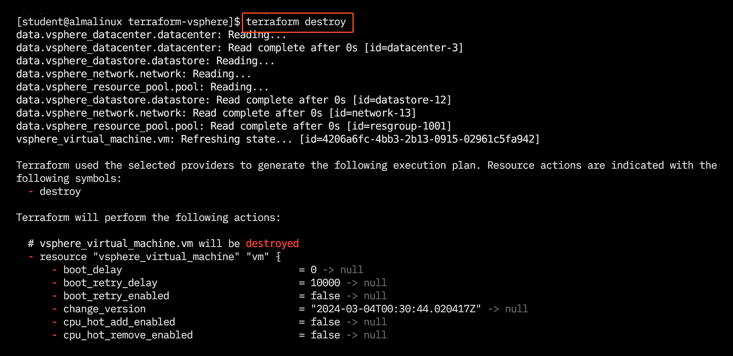
5. Verify that the VM has been destroyed in vSphere Client.  
   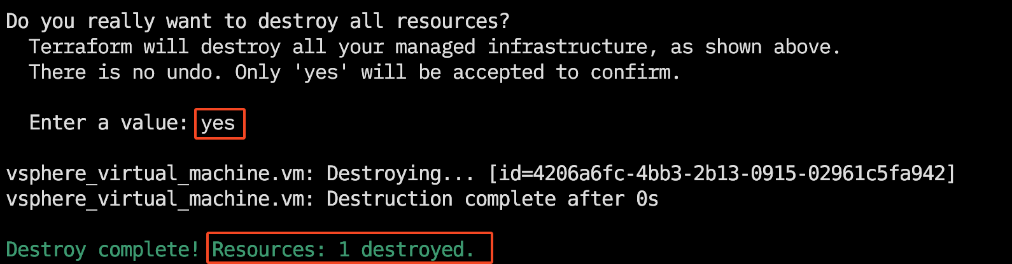
6. To protect sensitive information such as usernames, passwords and access tokens, declare input variables for the vCenter administrator username and password in the **secret.tfvars** file. Then, replace the hardcoded username and password in the **main.tf** file with references to **secret.tfvars** file.  
   For more information, read <https://developer.hashicorp.com/terraform/tutorials/configuration-language/sensitive-variables>

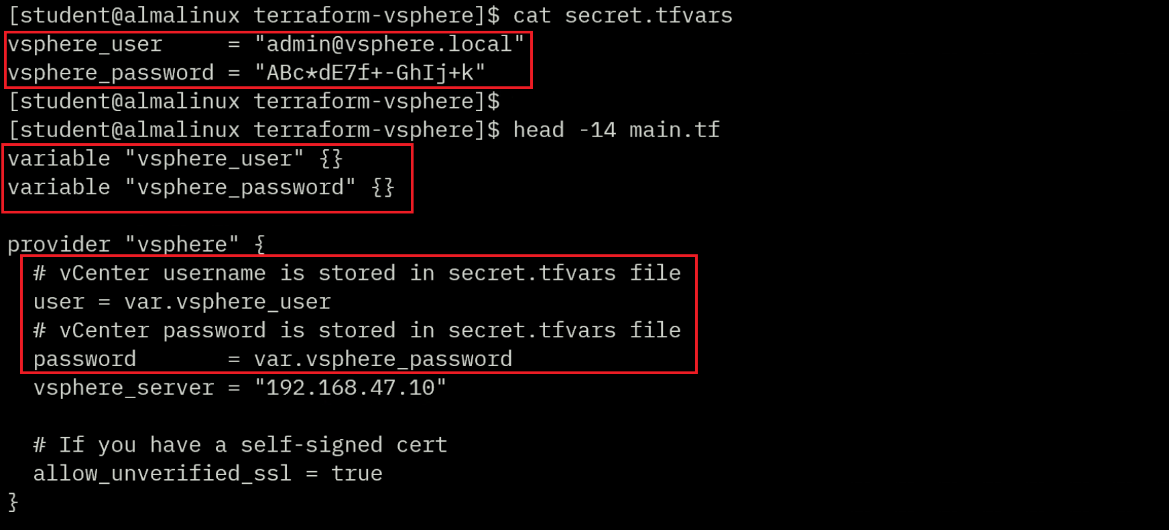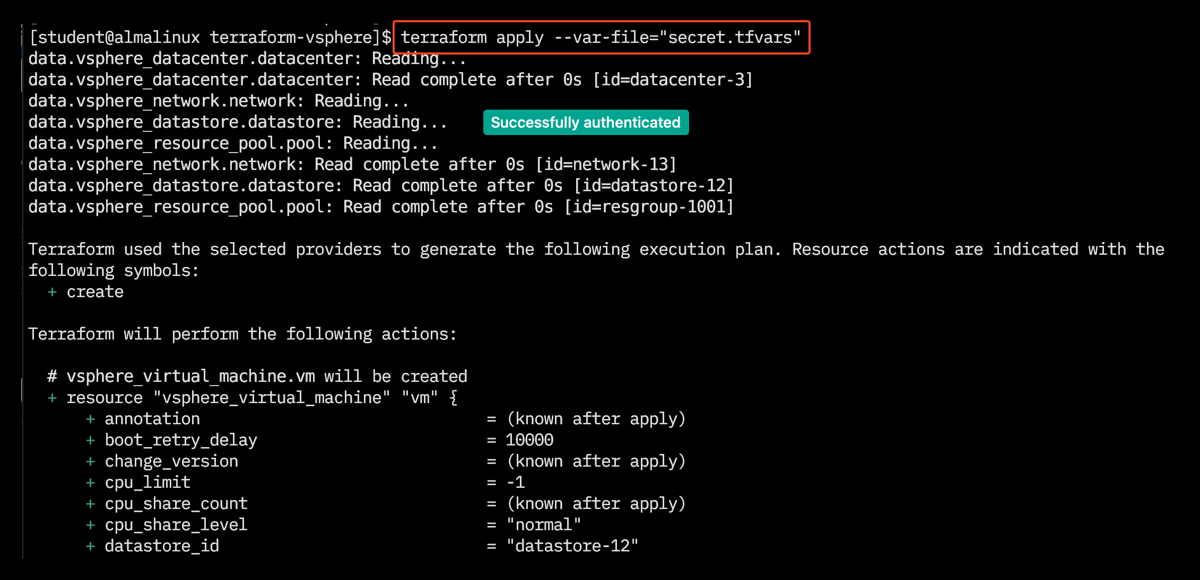

Figure 2: Set Sensitive Variables with .tfvars file

Source: HashiCorp, 2024. Reproduced and used in accordance with the fair dealing provisions in section 29 of the Canadian Copyright Act for the purposes of education, research or private study. Further distribution may infringe copyright.

1. Replace the **vsphere_password** with a wrong one in **secret.tfvars** file and try again. Observe the error message.  
   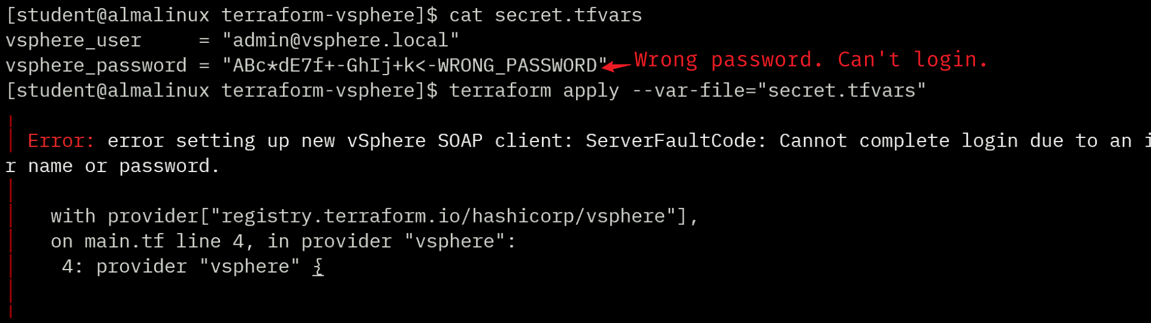
2. Set the right password and destroy the VM.
3. Configure the other ESXi to exit maintenance mode for Part D  
   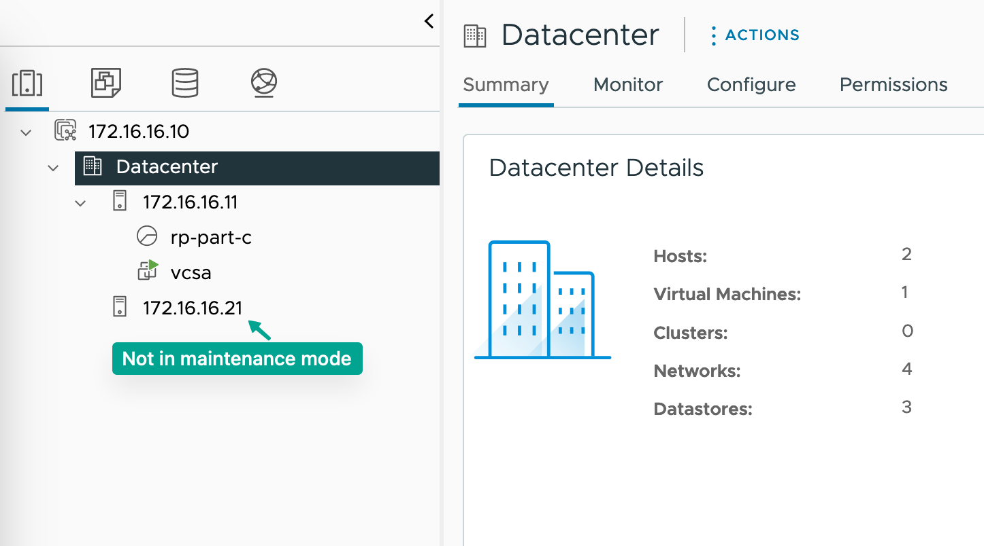

Demonstrate to your instructor now or record a demo video. Backup your **main.tf** to a different directory.

### Part D: Manage VMware Resources with Terraform

This part is **independent** of Part C. Work in a new directory or move ALL files (including hidden files) to a different directory. In this part of the project, you’ll write configuration code in a **NEW** **main.tf** to create a high availability cluster named “**iac-cluster**”, a resource pool and an NFS datastore.

1. Add the provider block from Part B.2 to the new **main.tf** file and initialize it. Modify the code from the “Example Usage” section of [Terraform’s vsphere_compute_cluster page](https://registry.terraform.io/providers/hashicorp/vsphere/latest/docs/resources/compute_cluster) (<https://registry.terraform.io/providers/hashicorp/vsphere/latest/docs/resources/compute_cluster>) and add it to **main.tf**
2. Run the command **terraform validate** to validate your configuration.  
   
3. The code in “Example Usage” is syntactically correct, but it contains a data type error that terraform will fail with error messages “data.vsphere_host.host is tuple with 2 elements” and “Inappropriate value for attribute "host_system_ids": element 0: string required.”  
   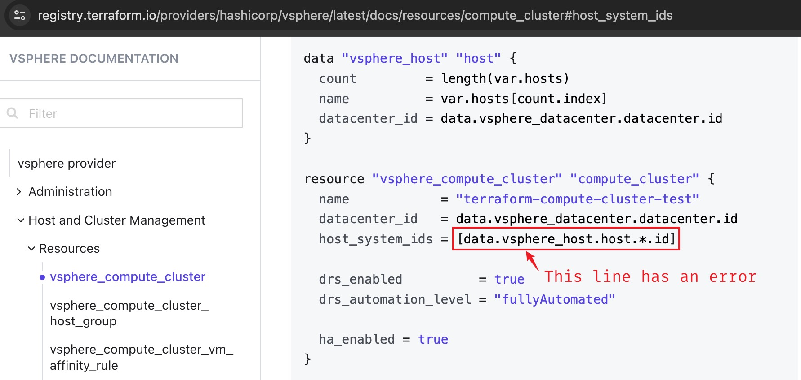  
   Errors are common in tech documents, and it is important for students to learn how to troubleshoot them. This is a valuable skill in the real world.
4. Output data from Terraform can be used to troubleshoot this error.  
   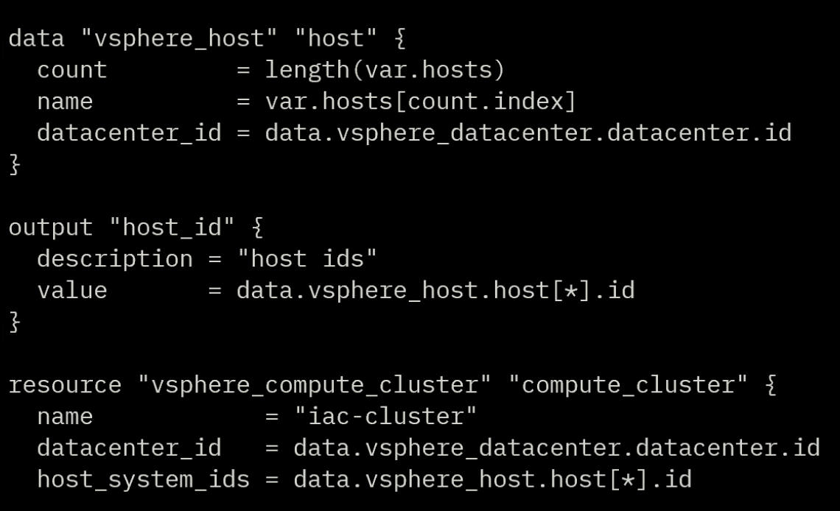
5. Create a high availability cluster and add two ESXi hosts to it by running the command **terraform apply**

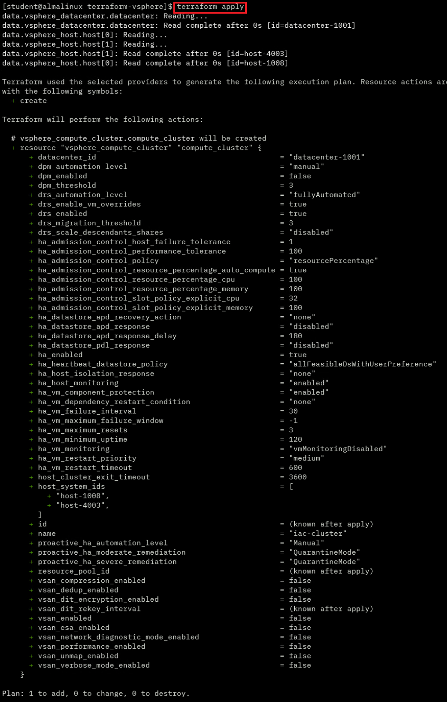

Figure 3. Terraform Apply Command

Source: HashiCorp, 2024. Reproduced and used in accordance with the fair dealing provisions in section 29 of the Canadian Copyright Act for the purposes of education, research or private study. Further distribution may infringe copyright.

1. When asked “Do you want to perform these actions?” type **yes** and then press **ENTER**.

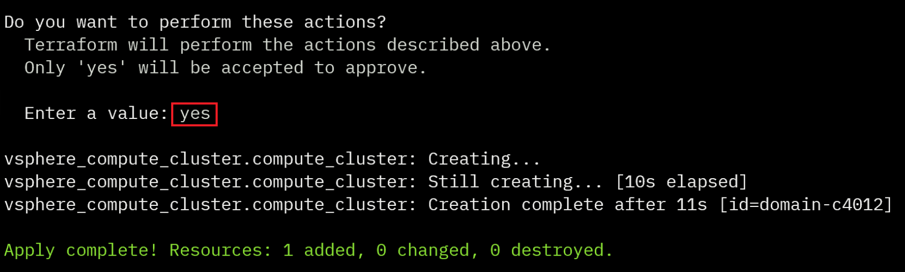

Figure 4: Create vSphere Compute Cluster

Source: HashiCorp, 2024. Reproduced and used in accordance with the fair dealing provisions in section 29 of the Canadian Copyright Act for the purposes of education, research or private study. Further distribution may infringe copyright.

1. Go to VMware vSphere Client and verify that the HA cluster was created successfully.

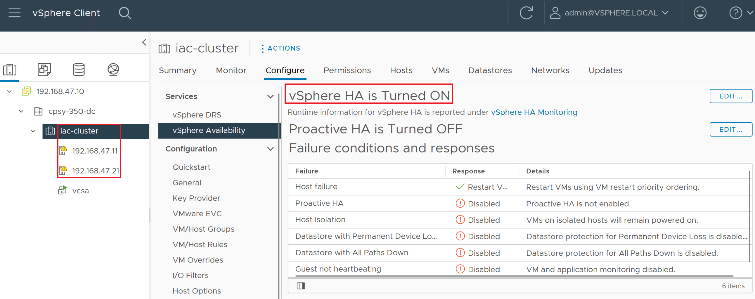

Figure 5: Verify the Created HA Cluster

Source: VMware, 2024. Reproduced and used in accordance with the fair dealing provisions in section 29 of the Canadian Copyright Act for the purposes of education, research or private study. Further distribution may infringe copyright.

1. Modify the code from the “Example Usage” section of [Terraform’s vsphere_resource_pool page](https://registry.terraform.io/providers/hashicorp/vsphere/latest/docs/resources/resource_pool) (<https://registry.terraform.io/providers/hashicorp/vsphere/latest/docs/resources/resource_pool>) and add it to **main.tf**.
2. Create a resource pool named “**resource-pool-YOUR_SAIT_ID**” by running the command **terraform apply**.
3. Simply modify the dc name, cluster name and resource pool name will not work.   
   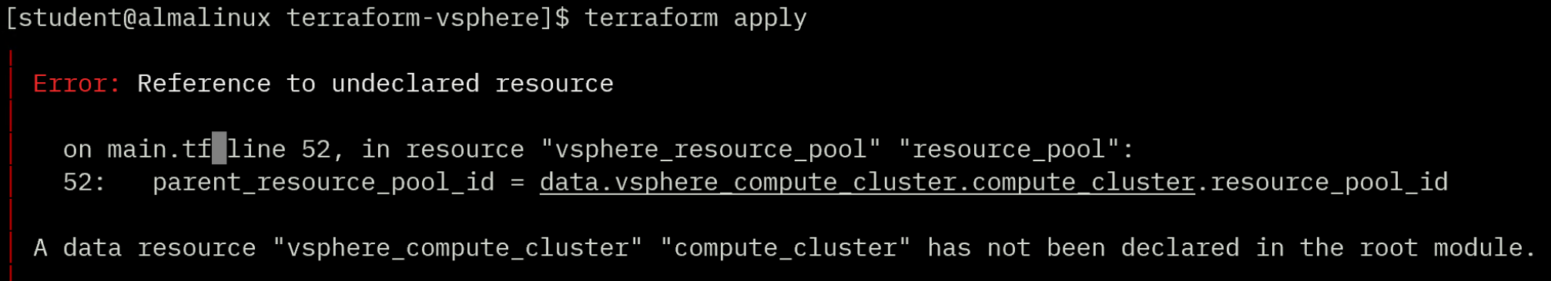

Hint: Compare the code between compute cluster example and resource pool example, have you noticed the difference?  
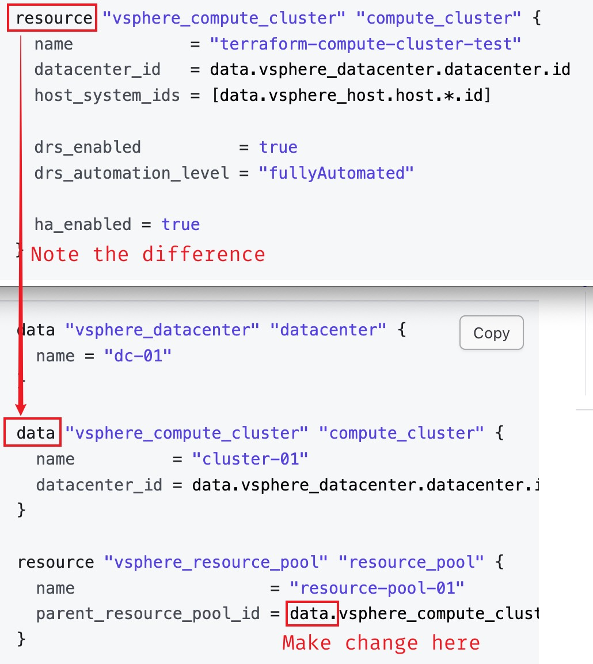

1. Fix the issue and re-run the command **terraform apply** to create the resource pool.

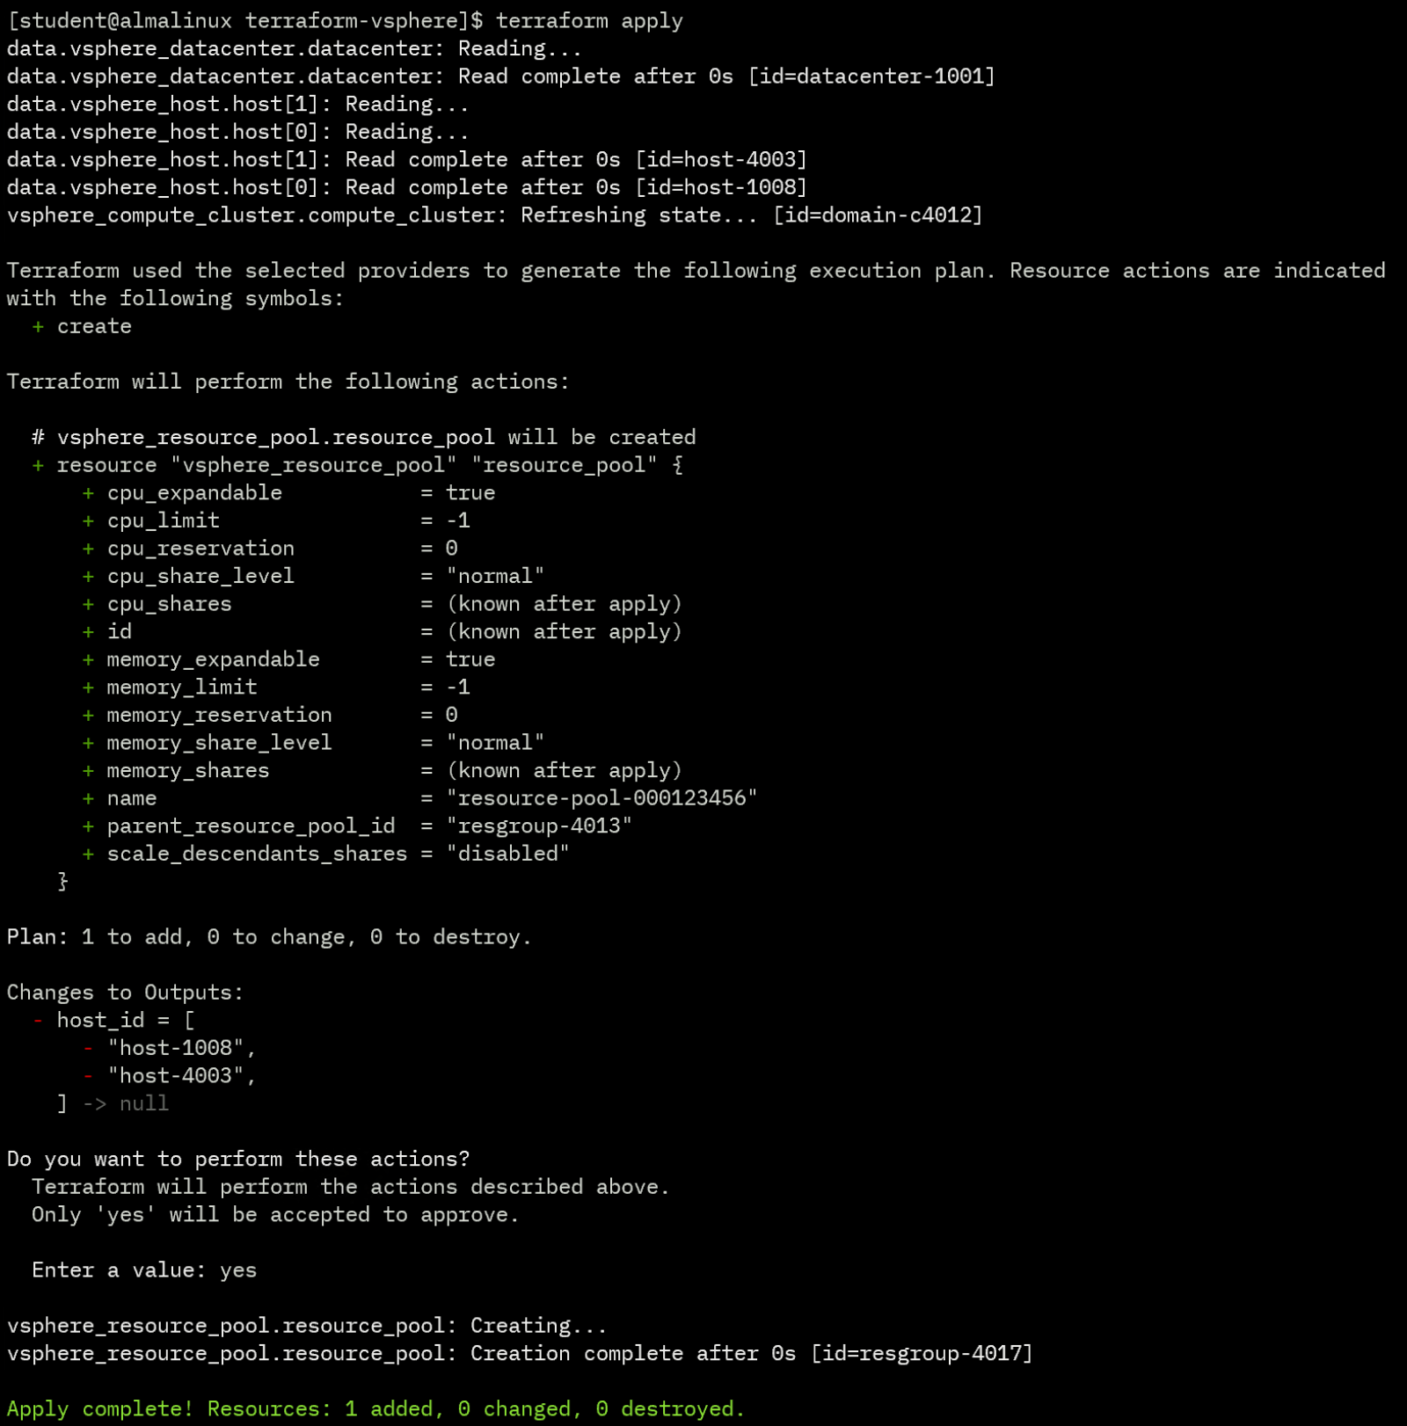

Figure 6: Create a Resource Pool

Source: HashiCorp, 2024. Reproduced and used in accordance with the fair dealing provisions in section 29 of the Canadian Copyright Act for the purposes of education, research or private study. Further distribution may infringe copyright.

1. Go to VMware vSphere Client and verify that the resource pool was created successfully.

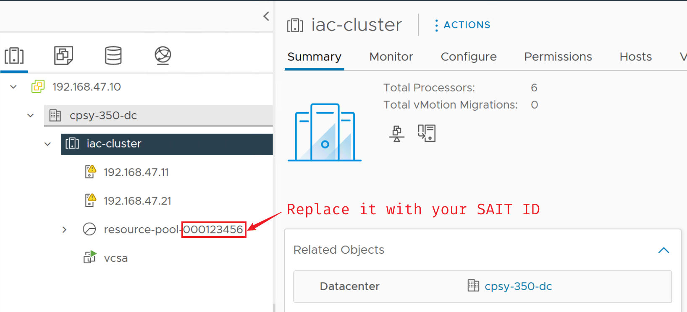

Figure 7: Verify the Created Resource Pool

Source: VMware, 2024. Reproduced and used in accordance with the fair dealing provisions in section 29 of the Canadian Copyright Act for the purposes of education, research or private study. Further distribution may infringe copyright.

1. Prepare an NFS server. Ensure that it is reachable from ESXi hosts.
2. Modify the code from the “Example Usage” section of [Terraform’s vsphere_nas_datastore page](https://registry.terraform.io/providers/hashicorp/vsphere/latest/docs/resources/nas_datastore) (<https://registry.terraform.io/providers/hashicorp/vsphere/latest/docs/resources/nas_datastore> ) and add it to **main.tf**.
3. The example code has similar error to Part D. 3.  
   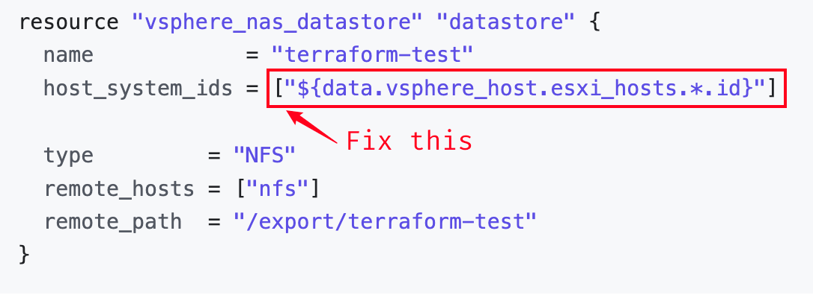
4. Find the fix at Part D. 4.
5. Create an NFS datastore named “**tf-nfs-ds-YOUR_SAIT_ID**” for ESXi hosts by running the command **terraform apply**.

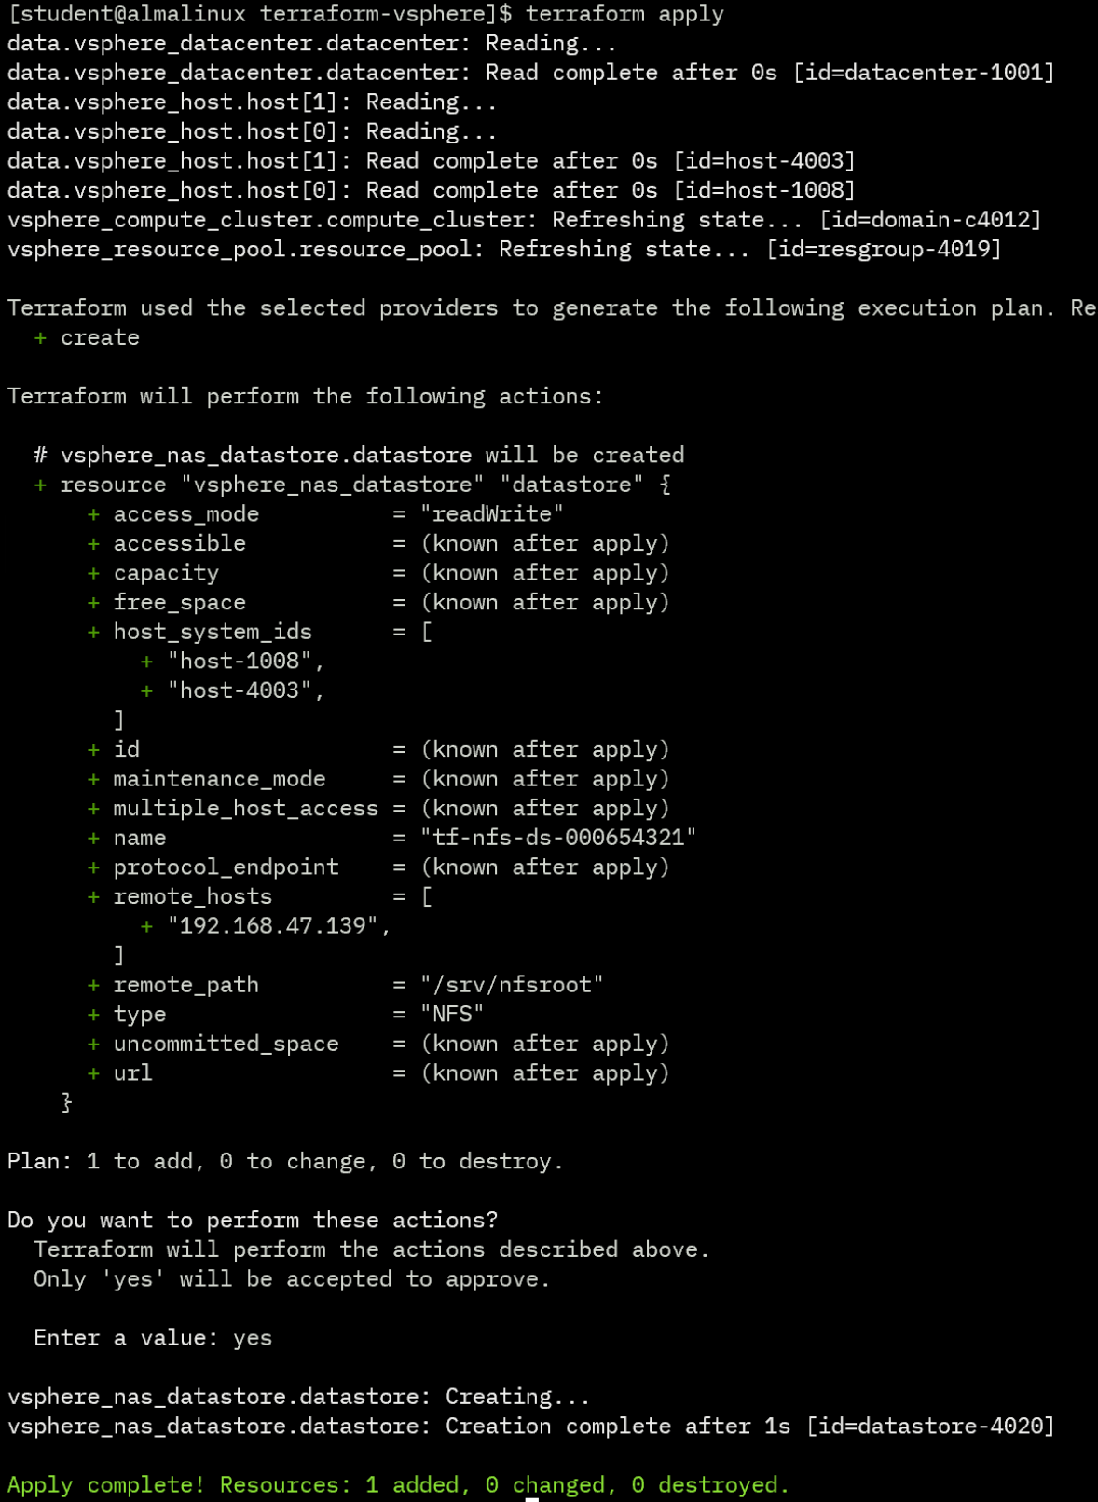

Figure 8: Create an NFS Datastore

Source: HashiCorp, 2024. Reproduced and used in accordance with the fair dealing provisions in section 29 of the Canadian Copyright Act for the purposes of education, research or private study. Further distribution may infringe copyright.

1. Go to VMware vSphere Client and verify that the datastore was created successfully.

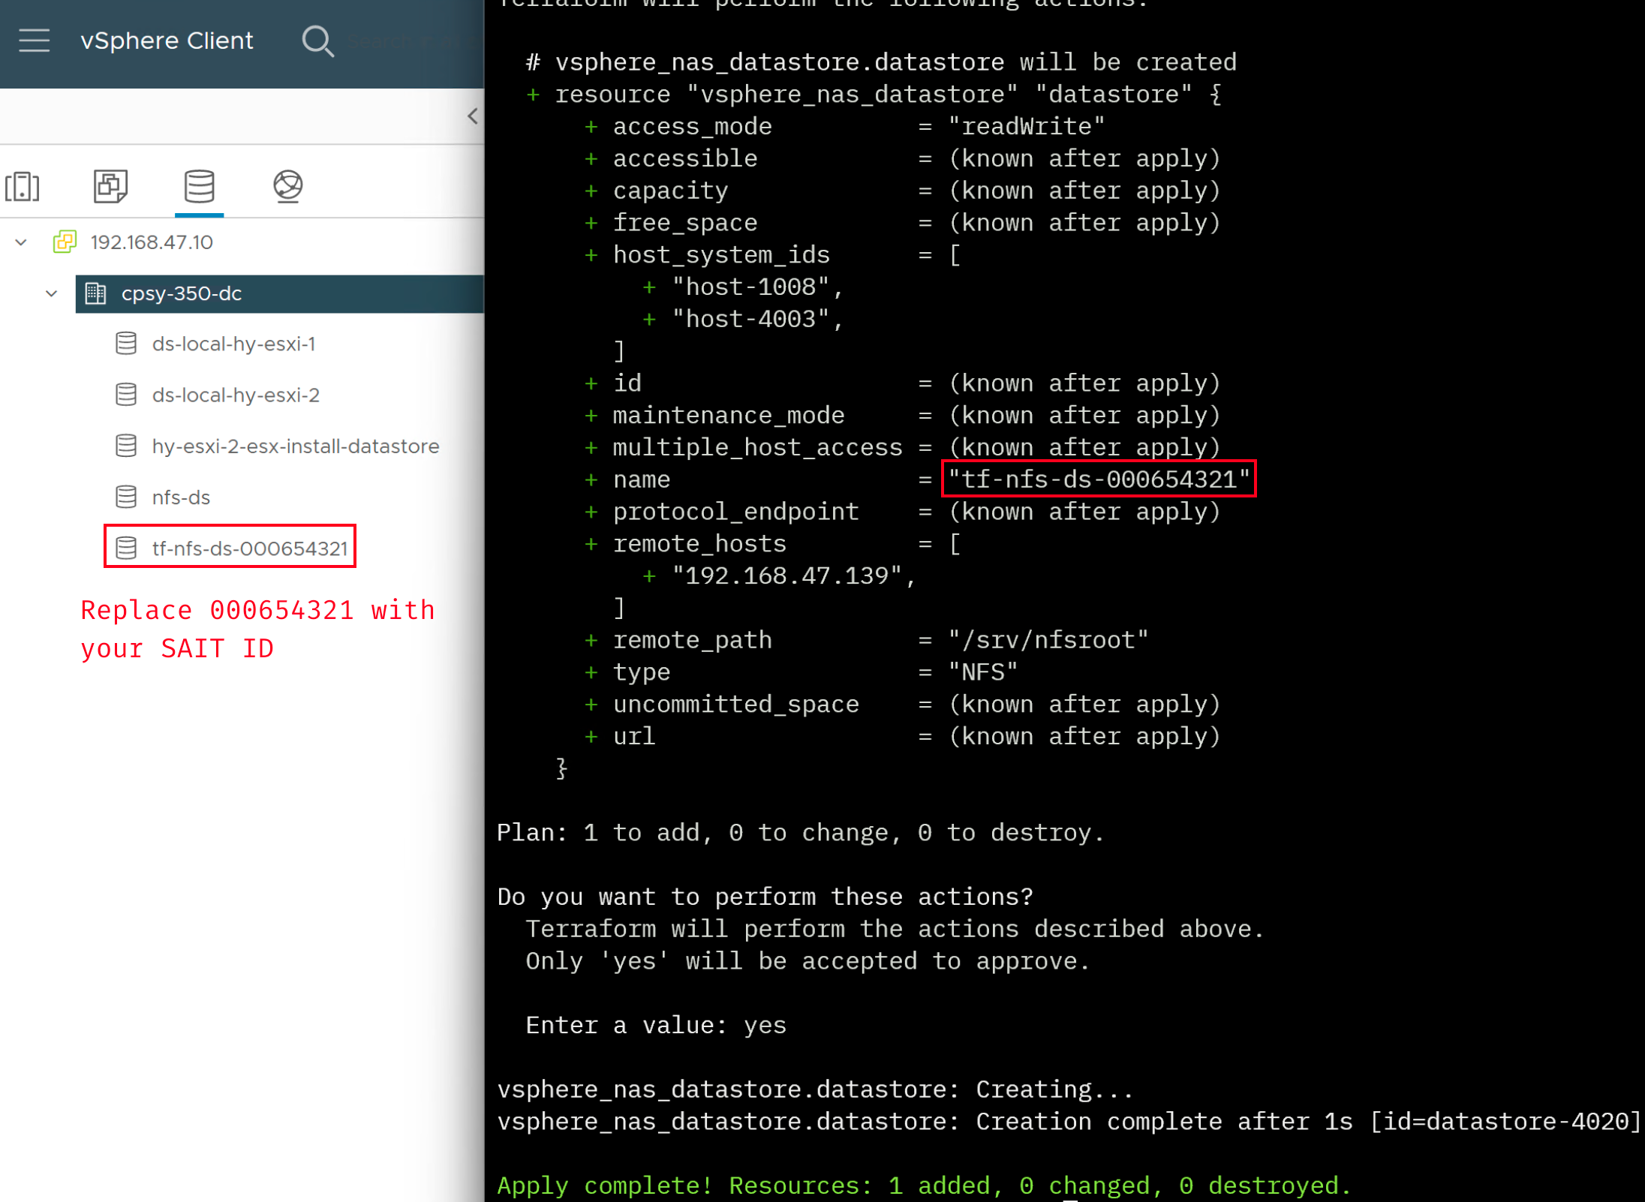

Figure 9: Verify the Created NFS Datastore

Source: VMware, 2024. Reproduced and used in accordance with the fair dealing provisions in section 29 of the Canadian Copyright Act for the purposes of education, research or private study. Further distribution may infringe copyright.

### Part E: Demonstrations

In this section, you will conduct a live demonstration of what you’ve learned for your instructor. Your instructor will indicate whether this portion of the project will occur face to face or online. See the marking criteria at the end of this document for details of how you will be assessed.

#### Project Demonstrations

1. **Demo 1:** Create a VM using Terraform.



Figure 12: Verify Virtual Machine Creation

Source: VMware, 2024. Reproduced and used in accordance with the fair dealing provisions in section 29 of the Canadian Copyright Act for the purposes of education, research or private study. Further distribution may infringe copyright.

1. **Demo 2:** Destroy the VM using Terraform and verify the destruction.
2. **Demo 3:** Demonstrate the protection of sensitive information. Demonstrate successful and unsuccessful authentication.
3. **Demo 4:** Create an HA cluster using Terraform.
4. **Demo 5:** Create a resource pool using Terraform.
5. **Demo 6:** Create an NFS datastore using Terraform.

## Marking Criteria

|  |  |  |  |  |  |
| --- | --- | --- | --- | --- | --- |
| **Criteria** | **Poor 0/5** | **Satisfactory 1/5** | **Good 3/5** | **Excellent 5/5** | **Marks** |
| **Demo 1: Create VM** | Fails to create VM. | Successfully creates a VM with incorrect settings. | N/A | Successfully create VM with correct settings. | /40 |
| **Demo 2: Destroy VM** | Fails to destroy VM. | N/A | N/A | Successfully destroys VM. | /10 |
| **Demo 3: Protect Sensitive Information** | Fails to protect sensitive information. | N/A | N/A | Successfully use sensitive variables to protect login credentials. | /20 |
| **Demo 4: Create HA Cluster** | Fails to create HA cluster. | Successfully creates a cluster but HA is not enabled. | N/A | Successfully creates HA cluster. | /10 |
| **Demo 5: Create Resource Pool** | Fails to create resource pool. | N/A | N/A | Successfully creates resource pool. | /10 |
| **Demo 6: Create NFS Datastore** | Fails to create NFS datastore. | Successfully creates a datastore with incorrect settings. | N/A | Successfully creates NFS datastore for all ESXi hosts. | /10 |
| **Total** | | | | | **/100** |

# Resources

* [Install Terraform](https://learn.hashicorp.com/tutorials/terraform/install-cli) (https://learn.hashicorp.com/tutorials/terraform/install-cli)
* [Terraform CLI Documentation](https://www.terraform.io/cli) (https://www.terraform.io/cli)
* [Terraform Language Documentation](https://www.terraform.io/language) (https://www.terraform.io/language)
* [Terraform vSphere Host and Cluster Management](https://registry.terraform.io/providers/hashicorp/vsphere/latest/docs/resources/compute_cluster) (https://registry.terraform.io/providers/  
  hashicorp/vsphere/latest/docs/resources/compute_cluster)
* [Terraform vSphere Storage](https://registry.terraform.io/providers/hashicorp/vsphere/latest/docs/resources/datastore_cluster) (https://registry.terraform.io/providers/hashicorp/vsphere/latest/  
  docs/resources/datastore_cluster)
* [Terraform vSphere Virtual Machine](https://registry.terraform.io/providers/hashicorp/vsphere/latest/docs/resources/virtual_machine) (https://registry.terraform.io/providers/hashicorp/  
  vsphere/latest/docs/resources/virtual_machine)
* [Infrastructure as Code for VMware with Terraform](https://www.youtube.com/watch?v=0-7JIuiFORA) [58:53] (https://www.youtube.com/watch?v=0-7JIuiFORA)

# References

HashiCorp (2024). Terraform Documentation. [Computer software]. Retrieved from https://www.terraform.io/docs

VMware, Inc. (2024). VMware vSphere (Version 7.0). [Computer software]. Retrieved from https://customerconnect.vmware.com/en/downloads/info/slug/datacenter_cloud_infrastructure/vmware_vsphere/7_0